

Semester One Examination, 2018

Question/Answer booklet

MATHEMATICS

SOLUTIONS
METHODS
UNIT 3

Section One:

Calculator-free

Student number: In figures

In words

Your name

Time allowed for this section
Reading time before commencing work: five minutes
Working time: fifty minutes

Materials required/recommended for this section
To be provided by the supervisor
This Question/Answer booklet
Formula sheet

To be provided by the candidate
Standard items: pens (blue/black preferred), pencils (including coloured), sharpener,
correction fluid/tape, eraser, ruler, highlighters

Special items: nil

Important note to candidates
No other items may be taken into the examination room. It is your responsibility to ensure that you do not have any unauthorised material. If you have any unauthorised material with you, hand it to the supervisor before reading any further.

Structure of this paper

Section | Number of questions available | Number of questions to be answered | Working  time (minutes) | Marks available | Percentage of examination
Section One:  Calculator-free | 8 | 8 | 50 | 52 | 35
Section Two:  Calculator-assumed | 13 | 13 | 100 | 98 | 65
 |  |  |  | Total | 100

Instructions to candidates

1. The rules for the conduct of examinations are detailed in the school handbook. Sitting this examination implies that you agree to abide by these rules.

2. Write your answers in this Question/Answer booklet.

3. You must be careful to confine your response to the specific question asked and to follow any instructions that are specified to a particular question.

4. Supplementary pages for the use of planning/continuing your answer to a question
have been provided at the end of this Question/Answer booklet. If you use these pages to continue an answer, indicate at the original answer where the answer is continued, i.e. give the page number.

5. Show all your working clearly. Your working should be in sufficient detail to allow your answers to be checked readily and for marks to be awarded for reasoning. Incorrect answers given without supporting reasoning cannot be allocated any marks. For any question or part question worth more than two marks, valid working or justification is required to receive full marks. If you repeat any question, ensure that you cancel the answer you do not wish to have marked.

6. It is recommended that you do not use pencil, except in diagrams.

7. The Formula sheet is not to be handed in with your Question/Answer booklet.

Section One: Calculator-free 35% (52 Marks)
This section has eight (8) questions. Answer all questions. Write your answers in the spaces provided.

Working time: 50 minutes.

Question 1 (6 marks)
A box contains five balls numbered $2, 3, 4, 5$ and $6$. Three balls are randomly drawn from the box at the same time and the random variable $X$ is the largest of the three numbers drawn.

(a) By listing all possible outcomes ($234$, $235$, etc.), determine $P(X≤5)$. (2 marks)
Solution
$$\left\{234, 235, 236, 245, 246, 256, 345, 346, 356, 456\right\}$$

$$P\left(X≤5\right)=\frac{4}{10}$$

Specific behaviours
lists outcomes
correct probability

(b) Construct a table to show the probability distribution of $X$. (2 marks)
Solution
$$x$$ | $$4$$ | $$5$$ | $$6$$
$$P(X=x)$$ | $$\frac{1}{10}$$ | $$\frac{3}{10}$$ | $$\frac{6}{10}$$
Specific behaviours
values of $x$
values of $P(X=x)$

(c) Calculate $E⁡(X)$. (2 marks)
Solution
$$E\left(X\right)=\frac{4+15+36}{10}=5.5$$

Specific behaviours
indicates products $x∙P(X=x)$
correct value

Question 2 (5 marks)
A function defined by $f\left(x\right)=13+18x-6x^{2}-2x^{3}$ has stationary points at $(1, 23)$ and $(-3, -41)$.

(a) Use the second derivative to show that one of the stationary points is a local maximum and the other a local minimum. (3 marks)
Solution
$$f^{'}\left(x\right)=18-12x-6x^{2}$$
$$f^{''}\left(x\right)=-12x-12$$

$$f^{''}\left(1\right)=-12\left(1\right)-12=-24<0⇒\left(1, 23\right)\text{ is a maximum}$$

$$f^{''}\left(-3\right)=-12\left(-3\right)-12=24>0⇒\left(-3, -41\right) \text{is a minimum}$$

Specific behaviours
differentiates twice
shows $f^{''}\left(1\right)<0$ and interprets
shows $f^{''}\left(-3\right)>0$ and interprets

(b) Determine the coordinates of the point of inflection of the graph of $y=f(x)$. (2 marks)
Solution
$$f^{''}\left(x\right)=0⇒x=-1$$

$$f\left(-1\right)=13-18-6+2=-9$$

$$\text{At} (-1, -9)$$

Specific behaviours
correct $x$-coordinate
correct $y$-coordinate

Question 3 (5 marks)
A particle travels in a straight line so that its distance $x$ cm from a fixed point $O$ on the line after $t$ seconds is given by
$$x=\frac{3t^{3}}{2t+1}, t≥0.$$

Calculate the acceleration of the particle when $t=1$.
Solution
$$v=\frac{9t^{2}\left(2t+1\right)-3t^{3}(2)}{{\left(2t+1\right)}^{2}} \\ =\frac{12t^{3}+9t^{2}}{{\left(2t+1\right)}^{2}}$$

$$a=\frac{(36t^{2}+18t){\left(2t+1\right)}^{2}-(12t^{3}+9t^{2})(2)(2)(2t+1)}{{\left(2t+1\right)}^{4}}$$

$$\left[=\frac{24t^{3}+36t^{2}+18t}{{\left(2t+1\right)}^{3}}\right]$$

$$a\left(1\right)=\frac{\left(54\right)\left(3^{2}\right)-(21)(4)(3)}{3^{4}}=\frac{54-28}{3^{2}}=\frac{26}{9} {\text{cm/s}}^{2}$$

Specific behaviours
correct form of quotient rule
simplifies expression for $v$
correct use of chain rule in second derivative
correct expression for acceleration
substitutes and simplifies

Question 4 (8 marks)
The graph of $y={\left(3-2x\right)}^{3}$ is shown below.

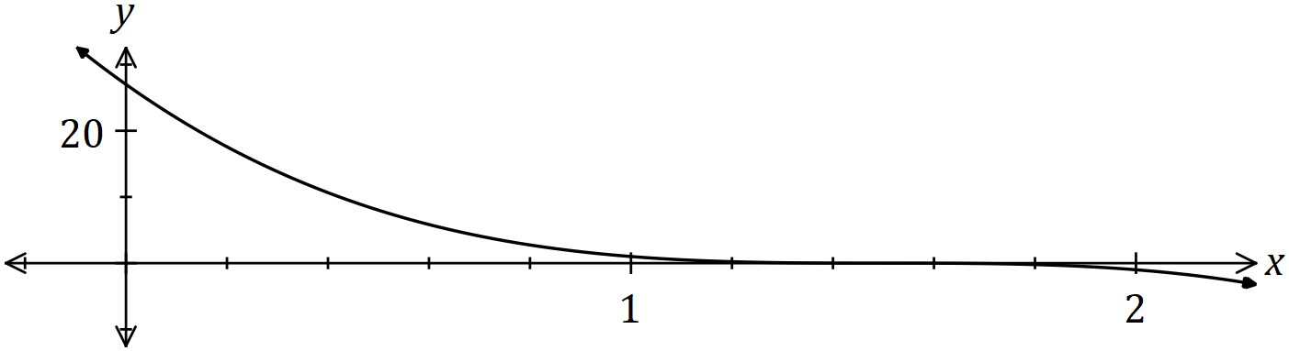

(a) Determine the area of the region enclosed by the curve and the coordinates axes.
(4 marks)
Solution
$$3-2x=0⇒x=1.5$$

$$A=\int_{0}^{1.5}{{\left(3-2x\right)}^{3}}dx \\ ={\left[\frac{{\left(3-2x\right)}^{4}}{-8}\right]}_{0}^{1.5} \\ =\left(0\right)-\left(\frac{81}{-8}\right) \\ =\frac{81}{8} \text{sq units}$$

Specific behaviours
writes integral with limits
antidifferentiates
expression with both limits substituted
correct area

(b) Given that the area of the region bounded by the curve, the $x$-axis and the line $x=k$ is $8$ square units, determine the value of $k$, where $0<k<1.5$. (4 marks)
Solution
$$A=\int_{k}^{1.5}{{\left(3-2x\right)}^{3}}dx⇒8={\left[\frac{{\left(3-2x\right)}^{4}}{-8}\right]}_{k}^{1.5}$$
$$8=\left(0\right)-\left(\frac{{\left(3-2k\right)}^{4}}{-8}\right)$$
$${\left(3-2k\right)}^{4}=64$$
$$3-2k=\sqrt{8}$$

$$2k=3-2\sqrt{2}$$
$$k=\frac{3}{2}-\sqrt{2}$$

Specific behaviours
equation with antiderivative
equation with both limits substituted
simplifies equation
value of $k$

Question 5 (7 marks)
Determine $\begin{matrix}dy \\ \overline{dx}\end{matrix}$ for the following, simplifying each answer.

(a) $y=\sqrt{5-6x}$. (2 marks)
Solution
$$y={\left(5-6x\right)}^{\frac{1}{2}}$$

$$\frac{dy}{dx}=\frac{1}{2}\left(-6\right){\left(5-6x\right)}^{-\frac{1}{2}}$$

$$=-\frac{3}{\sqrt{5-6x}}$$

Specific behaviours
indicates use of chain rule
correct derivative, simplified

(b) $y=3x^{4}\sin{(4x)}$. (3 marks)
Solution
$$\frac{dy}{dx}=12x^{3}\sin\left(4x\right)+3x^{4}\left(4\right)\cos\left(4x\right)$$

$$=12x^{3}\sin\left(4x\right)+12x^{4}\cos\left(4x\right)$$

Specific behaviours
indicates use of product rule
correct derivative of $\sin{(4x)}$
correct derivative

(c) $y=\int_{x}^{2}{\underset{ }{\overset{ }{\begin{matrix}1 \\ \overline{\sqrt{1+t}}\end{matrix}}}}dt$. (2 marks)

Solution
$$\frac{dy}{dx}=-\int_{2}^{x}{\frac{1}{\sqrt{1+t}}} dt \\ =-\frac{1}{\sqrt{1+x}}$$

Specific behaviours
reverse limits
correct derivative

Question 6 (5 marks)
The height, in metres, of a lift above the ground $t$ seconds after it starts moving is given by

$$h=2\cos^{2}\left(\begin{matrix}t \\ \overline{5}\end{matrix}\right).$$

Use the increments formula to estimate the change in height of the lift from $t=\begin{matrix}5π \\ \overline{ 6 }\end{matrix}$ to $t=\begin{matrix}17π \\ \overline{ 20 }\end{matrix}$.
Solution
$$\frac{dh}{dt}=2×2×\cos\left(\frac{t}{5}\right)×\frac{d}{dt}\left(\cos\left(\frac{t}{5}\right)\right) \\ =-\frac{4}{5}\cos\left(\frac{t}{5}\right)\sin\left(\frac{t}{5}\right)$$

$$δt=\frac{17π}{20}-\frac{5π}{6}=\frac{π}{60}$$

$$δh≈-\frac{4}{5}\cos\left(\frac{5π}{6×5}\right)\sin\left(\frac{5π}{6×5}\right)×\frac{π}{60} \\ ≈-\frac{4}{5}×\frac{\sqrt{3}}{2}×\frac{1}{2}×\frac{π}{60} \\ ≈-\frac{\sqrt{3}π}{300} \text{m}$$

Specific behaviours
correctly uses chain rule
correct derivative
increment of time
substitutes correctly into increments formula
fully simplifies

Question 7 (9 marks)
The function $g$ is such that $g^{'}\left(x\right)=ax^{2}+18x+b$, it has a point of inflection at $(-1, 29)$ and a stationary point at $(1, -19)$.

(a) Determine $g(2)$. (5 marks)
Solution
$$g^{''}\left(x\right)=2ax+18$$
$$g^{''}\left(-1\right)=-2a+18=0⇒a=9$$

$$g^{'}\left(1\right)=0⇒9+18+b=0$$
$$b=-27$$

$$g^{'}\left(x\right)=9x^{2}+18x-27$$
$$g\left(x\right)={3x}^{3}+9x^{2}-27x+c$$

$$g\left(1\right)=-19⇒3+9-27+c=-19$$
$$c=-4$$

$$g\left(2\right)=24+36-54-4=2$$

Specific behaviours
value of $a$
value of $b$
antiderivative
constant of integration
value

(b) Determine

(i) $\int_{1}^{2}{\underset{ }{\overset{ }{g'(x)}}}dx$. (2 marks)
Solution
$$\int{g^{'}\left(x\right)}=Δy=2-\left(-19\right)=21$$

Specific behaviours
uses total change
correct value

(ii) $\int_{1}^{2}{\underset{ }{\overset{ }{4g'(x)}}+16}dx$. (2 marks)
Solution
$$4\int_{1}^{2}{g'(x)}dx+\int_{1}^{2}{16}dx=4\left(21\right)+16=100$$

Specific behaviours
uses linearity
correct value

Question 8 (7 marks)
Two houses, $P$ and $Q$, are $900$ m apart on either side of a straight railway line $AC$. $AC$ is the perpendicular bisector of $PQ$ and the midpoint of $PQ$ is $B$. A small train, $R$, leaves station $C$ and travels towards $B$, $1200$ m from $C$.

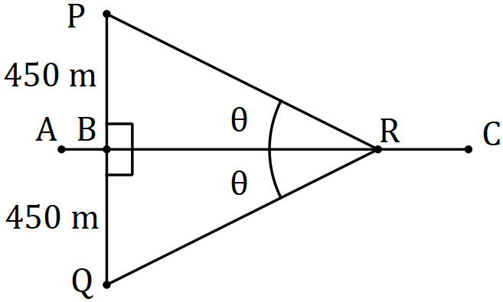

Let $∠PRB=∠QRB=θ$, where $0<θ<90°$, and $X=PR+QR+CR$, the sum of the distances of the train from the houses and station.

(a) By forming expressions for $PR, BR$ and $CR$, show that $X=1200+\begin{matrix}450(2-\cos{θ}) \\ \overline{\sin{θ} }\end{matrix}$ .
(3 marks)
Solution
$$PR=\frac{450}{\sin{θ}}, BR=PR\cos{θ}=\frac{450\cos{θ}}{\sin{θ}}, CR=1200-BR=1200-\frac{450\cos{θ}}{\sin{θ}}$$

$$X=2×\frac{450}{\sin{θ}}+1200-\frac{450\cos{θ}}{\sin{θ}}=1200+\frac{450\left(2-\cos{θ}\right)}{\sin{θ}}$$

Specific behaviours
expression for $PR$ in terms of $θ$
expressions for $BR$ and $CR$ in terms of $θ$
expression for $X$ in terms of $θ$

(b) Use a calculus method to determine the minimum value of $X$. (4 marks)
Solution
$$\frac{dX}{dθ}=450\left(\frac{\sin{θ}×\sin{θ}-\left(2-\cos{θ}\right)(\cos{θ})}{\sin^{2}{θ}}\right) \\ =450\left(\frac{\sin^{2}{θ}+\cos^{2}{θ}-2\cos{θ}}{\sin^{2}{θ}}\right) \\ =450\left(\frac{1-2\cos{θ}}{\sin^{2}{θ}}\right)$$

$$\frac{dX}{dθ}=0⇒\cos{θ=\frac{1}{2}⇒}θ=60°$$

$$X_{MIN}=1200+\frac{450\left(2-\cos{θ}\right)}{\sin{θ}}=1200+450\left(\frac{3}{2}\right)×\frac{2}{\sqrt{3}}=1200+450\sqrt{3} \text{m}$$

Specific behaviours
uses quotient rule
simplifies derivative
roots of derivative
minimum value of $X_{MIN}$

Supplementary page

Question number: _________

© 2018 WA Exam Papers. All Saints' College has a non-exclusive licence to copy and communicate this document for non-commercial, educational use within the school. No other copying, communication or use is permitted without the express written permission of WA Exam Papers. SN001-115-3.

